
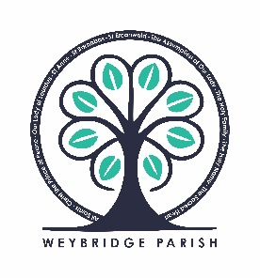
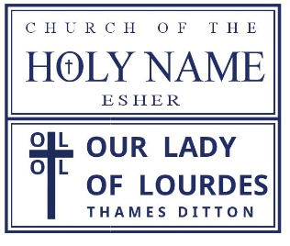

Masses Saturday 530pm & Sunday 11am at Our Lady of Lourdes
Masses Sunday 9am & 6pm at Church of the Holy Name

Our Lady of Lourdes
Hampton Court Way
Thames Ditton KT7 0LP
020 8398 2191
thamesditton@abdiocese.org.uk
Church of the Holy Name
42 Arbrook Lane,
Esher KT10 9EE
01372 462451
esher@abdiocese.org.uk

Grow in Discipleship
Adult Formation |  | Catechesis: (Baptism,  First Holy Communion, Confirmation) |  | Junior Church at Sunday Mass
Connect with each Other
Welcoming |  | Serving Coffee after Mass |  | Social Events
Fundraising |  | Church Cleaning |  | Flowers
Professional Skills |  | (Please Specify Relevant Skills):
Encounter Jesus
Music |  | Reading |  | Altar Serving
Adoration
Love the World
Care Team |  | Befriending the Bereaved |  | Social Justice
Repository |  | Charities & Community Team |  | Giving My Time

New Parishioner Form
Our Church Ministries
If you would like to become involved in our churches, please tick the appropriate boxes
Please complete in BLOCK capitals – if any details change, please let us know
Household Details:
Family Name:
Address: |  |  |  |  |  |  | Postcode: |  |  | Home Telephone No:
Usual Church / Mass attended
Title: Mr / Mrs / Miss / Ms / Other …………...
First Name: |  |  | Surname: |  |  |  |  |  | Mobile No:
Email: (one character per box please) |  |  |  |  | Occupation:
Roman Catholic: Yes/No | Other: |  |  |  |  |  |  |  | First Language:
Title: Mr / Mrs / Miss / Ms / Other …………...
First Name: |  |  | Surname: |  |  |  |  |  | Mobile No:
Email: (one character per box please) |  |  |  |  | Occupation:
Roman Catholic: Yes/No |  | Other: |  |  |  |  |  |  | First Language:
Children (or other resident family members) living at this address. Use back of form if needed.
Full Name: |  |  |  | Male/Female: |  | Date of Birth: |  | Baptised Y/N: |  |  | School:
Gift Aid & Donations
Please tick this box if you are a UK taxpayer and would like the parish to reclaim tax under the Gift Aid scheme.
Standing orders is our preferred method for donations to Account Name: RCD Arundel & Brighton The Holy Family,
Account Number: 21077287, Sort Code: 40-05-20 – Reference: Family name

Signed ……………………………………………………………………... Date ………………………………………..

(Please sign giving your consent for your Parish and the Diocese to retain the above information)
This data will be held in accordance with the Data Protection Act 1988 and will be used to keep you up to date with information regarding activities, initiatives and events within the Parish and Diocese. This data will not be shared outside of the Diocese. Please keep us informed of any changes to your contact details and we will update our database accordingly. When the information is no longer required, we will delete it from the database when requested.

