On 19th January the Representative Group of the newly formed Parish of Weybridge met for the third time, and Chris Bourne, Karen Haizelden as well as Kayleigh Calvin] were there from Esher and Thames Ditton

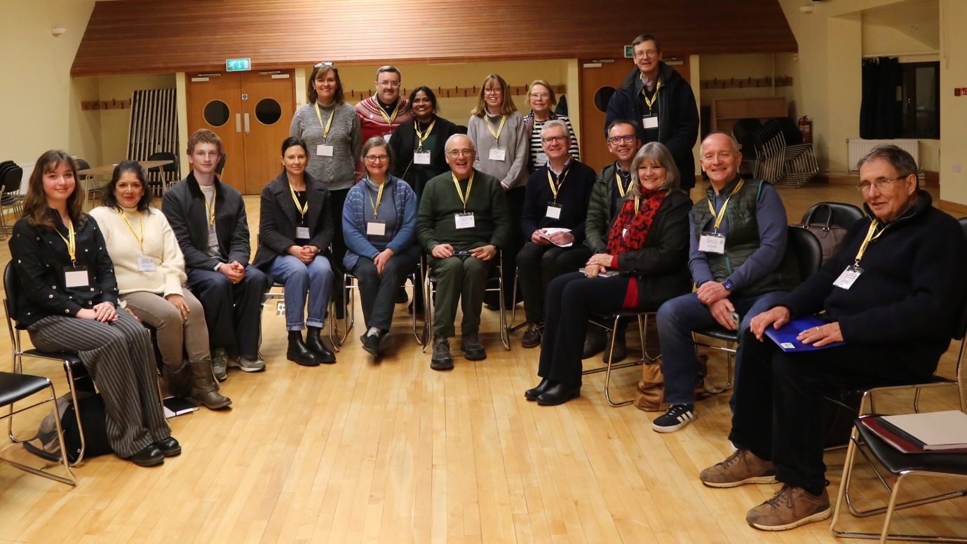

The Representatives reviewed a summary document of the open meetings which took place in November 2025 (in Englefield Green, Weybridge and Walton-on-Thames). We attach this document for all parishioners to read It shows overall enthusiasm for the new structure and the opportunity for mission and renewal, with some concerns expressed about stability of priests, the identity of parish communities and finances.

At the meeting of 19th January, the representatives were asked two questions. The first was – “What would be your hope for where we will be as a parish by the end of 2026?”

The responses highlighted the importance of making the new parish a reality for all parishioners. Ideas centred around a) communication, for example the creation of a parish newsletter b) events bringing people together c) going on pilgrimage together eg Fr Chris is leading a pilgrimage to Medjugorje d) a new parish website.

Great support was expressed for the recruitment of a Youth Ministry coordinator. There is also the need for an Estates Officer who can assist parish communities very practically in managing their different church buildings and annexes.

The representatives would like to see better representation of young families in the new parish, and for it to reflect the diversity of different groups that make up the parish.

Concern was expressed by the parish community of Esher/Thames Ditton with the absence of Fr Sebastian who is not well. Their hope in 2026 is for more stability in the provision of masses, as currently this is challenging. Please keep Fr Sebastian in your prayers.

The second question was about how representatives can assure communication with their parish communities. Representatives understand that they are the key channel of communication with their pastoral teams and clergy. One of the key messages is that we are all responsible for ensuring that we grow together, that we respond together, that we become that unified parish.

One of our younger representatives talked about the power of social media and Catholic podcasts to share a better understanding of what it means to be a Catholic today.

We end this update with a message from Canon Chris Spain, the Moderator of the new parish:
Even though the Holy Year is over, I hope we continue to journey forward as “Pilgrims of hope”. We never know what is around the next corner but continue as “earthen vessels” to serve God in humility and aware of the rich treasure we carry. We are so blessed in our new parish with energy and enthusiasm, and I am sure that great things will happen. We need patience and perseverance “Rome wasn’t built in a day”. God bless and thank you.”

The Parish Steering Group and Clergy are very grateful to the Representatives for their enthusiasm in coming to the meeting, sharing their hopes and thoughts and giving their time in this way.

The next Representatives meeting will be in April, the date is still to be fixed. Please feel free to contact your representative (PPC) if you have any question.

